**MARKETPLACE HACKATHON 2025**

**(DAY 7)**

**LIVE DEPLOYMENT AND POST LAUNCH PRACTICES**

**ENVIRONMENTAL SETUP**

NEXT_PUBLIC_SANITY_PROJECT_ID=""

NEXT_PUBLIC_SANITY_DATASET=""

SANITY_API_TOKEN="s"

NEXT_PUBLIC_CLERK_PUBLISHABLE_KEY=pk_test_

CLERK_SECRET_KEY=sk_test_

**SECURE HOSTING**

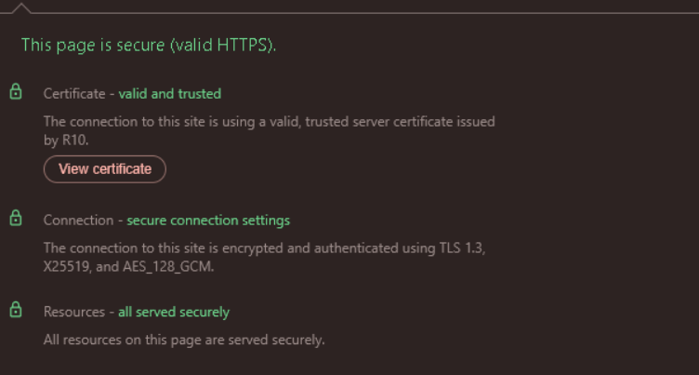

MONITORING

DESKTOP:



MOBILE:



***Bussiness pitch desk***

## 1. Introduction

### a. Marketplace Name

**Rental E-Commerce**

### b. Overview

Rental E-Commerce is an advanced online platform designed to facilitate the rental process of vehicles efficiently. It provides a seamless browsing experience for users to explore a variety of rental cars, view their specifications, check availability, and reserve their preferred vehicles for specific dates and times.

## 2. Problem Statement & Objectives

Develop a fast, responsive, and visually appealing website to attract and retain customers.

Ensure a user-friendly interface that offers an intuitive and smooth booking experience.

Display clear and concise information to assist users in making informed rental decisions.

Incorporate high-quality images of rental vehicles with detailed descriptions, including:

Hourly and daily rental rates

Car categories and available models

Key features such as fuel type, transmission, and seating capacity

Available color options

## 3. Key Features

### a. User-Friendly Interface

Responsive design for seamless use across different devices.

Simple navigation with clear categorization of vehicles.

### b. Vehicle Listings & Filtering

Advanced filtering options based on price, model, category, and features.

High-resolution images showcasing each rental car.

### c. Booking & Availability System

Real-time availability check for rental cars.

Date and time selection for a hassle-free reservation process.

### d. Secure Payment Integration

Multiple payment methods including credit/debit cards, JazzCash, EasyPaisa, and cash on delivery.

Secure transaction processing with confirmation messages upon successful booking.

### e. Customer Support & Assistance

Integrated customer support options for inquiries and booking-related issues.

FAQ section for quick troubleshooting and guidance.

## 4. Technology Stack

**Frontend:** Next.js (React framework), Tailwind CSS for styling.

**Backend:** Node.js with Express for API handling.

**Database:** MongoDB / Firebase for managing user and rental data.

**Authentication:** Firebase Authentication / NextAuth.js.

**Payment Gateway:** Stripe for online transactions.

**Hosting & Deployment:** Vercel / AWS.

## 5. User Workflow

Users visit the website and browse available rental cars.

They apply filters to find their preferred vehicle.

Users select a car and review its specifications and rental rates.

They proceed to book the car by selecting the rental period.

Payment is processed, and confirmation is sent via email or SMS.

Users receive booking details along with pickup/drop-off instructions.

## 6. Conclusion

The Rental E-Commerce platform is designed to enhance the car rental experience by providing a smooth, user-friendly, and efficient system. With an engaging UI/UX, real-time availability tracking, and secure payment options, users can effortlessly find and book their preferred vehicles.